**Monitor performance of virtual machines by using Azure Monitor VM Insights**

1. After setting up the environment and making monitoring logs the map looks like this

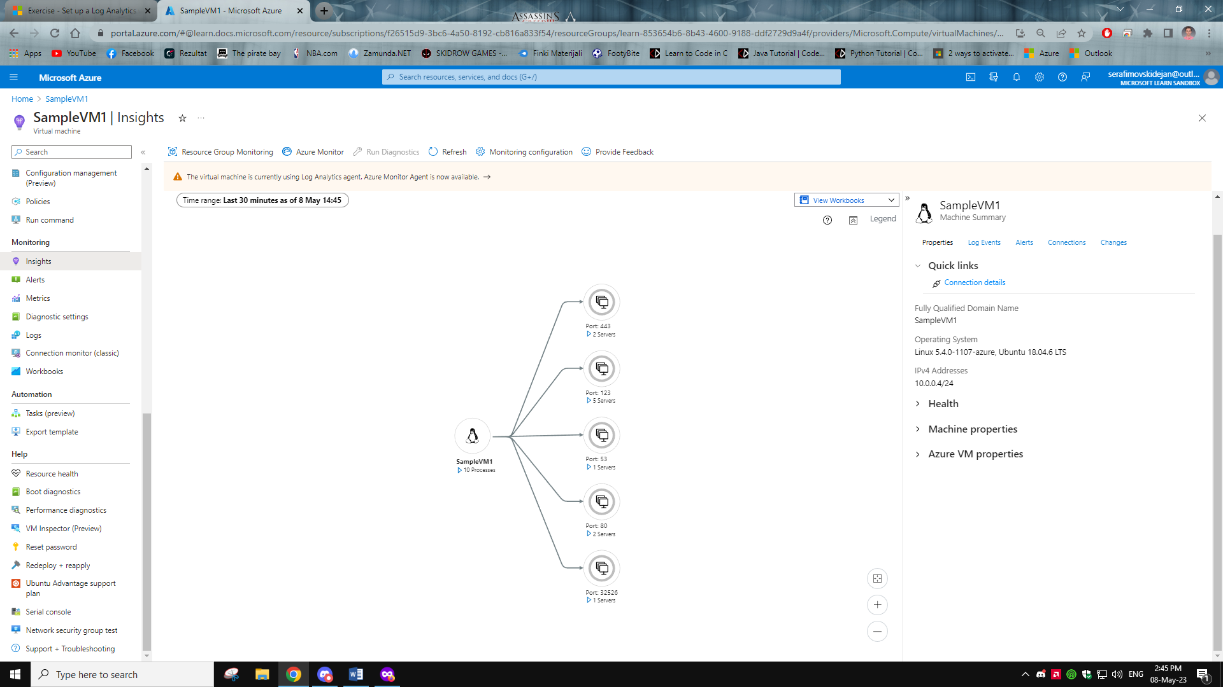

1. This is the performance tab

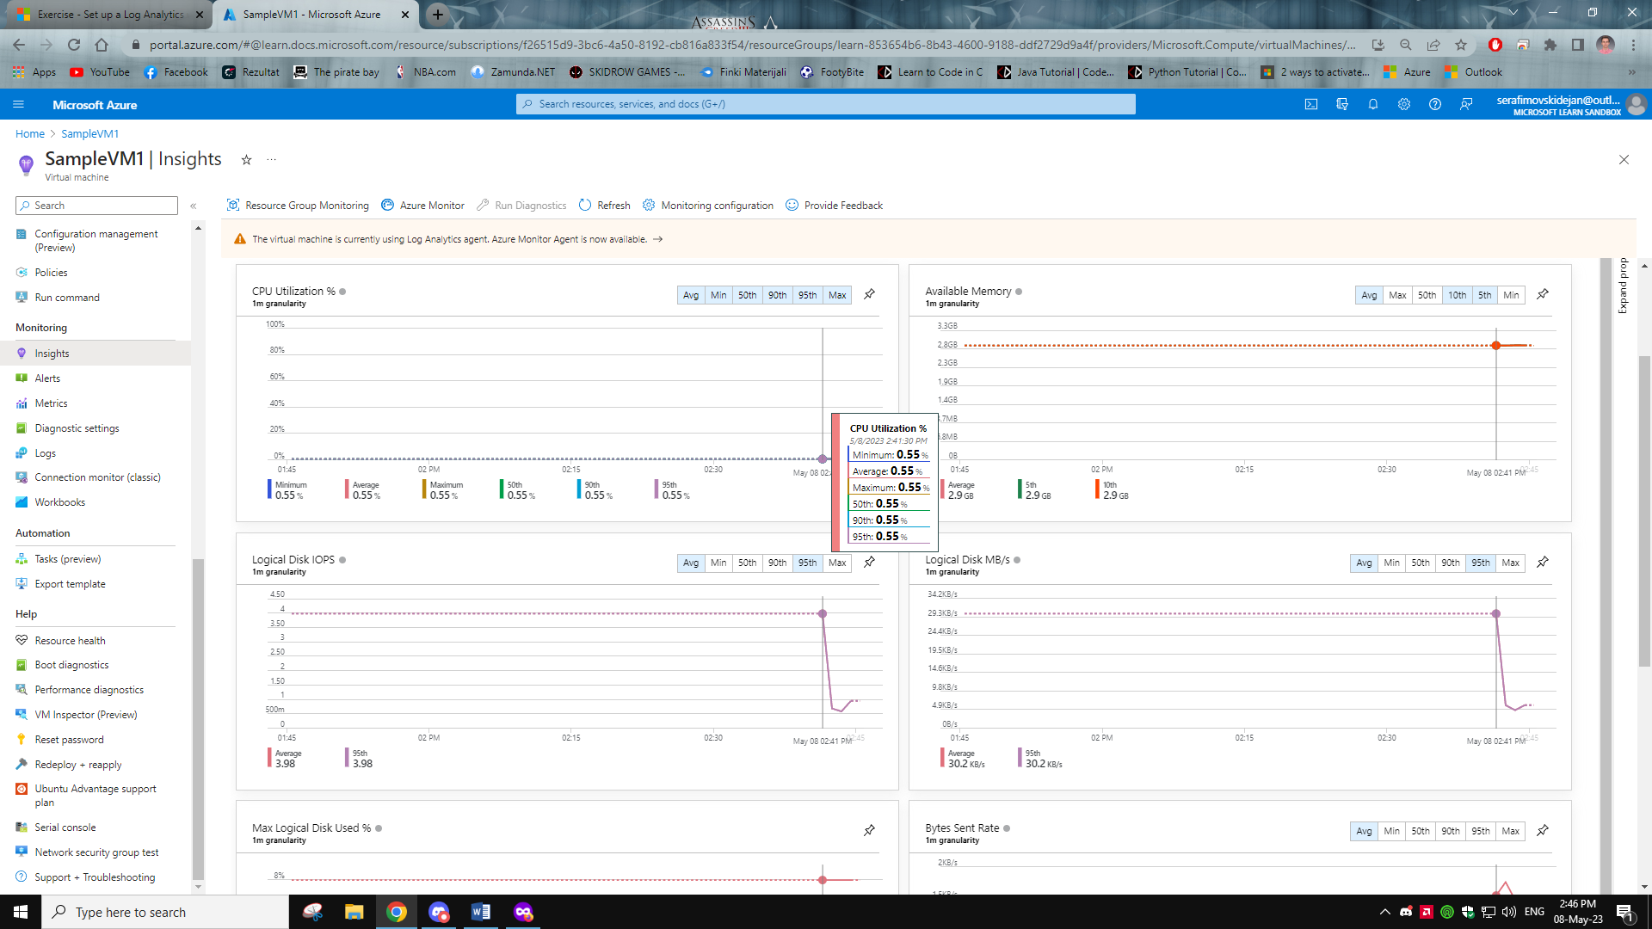

1. Here we can see the log events by count

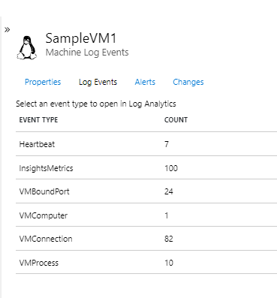

1. After opening the InsightsMetrics we can se how they are collected with log queries

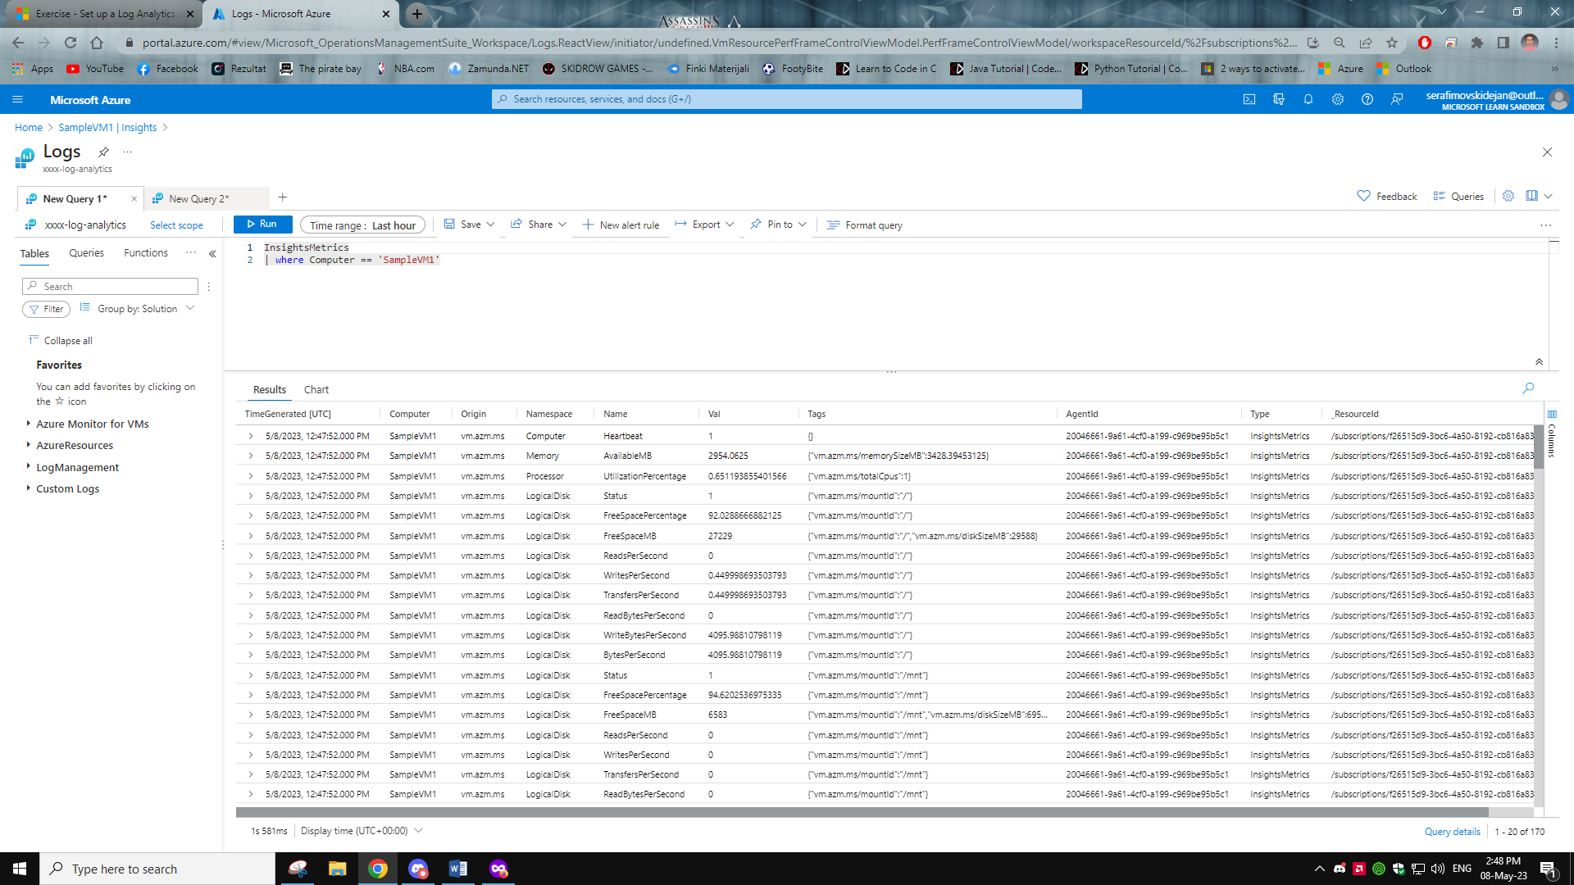

1. Here I just typed Heartbeat to test it and it showed all the Heartbeat logs

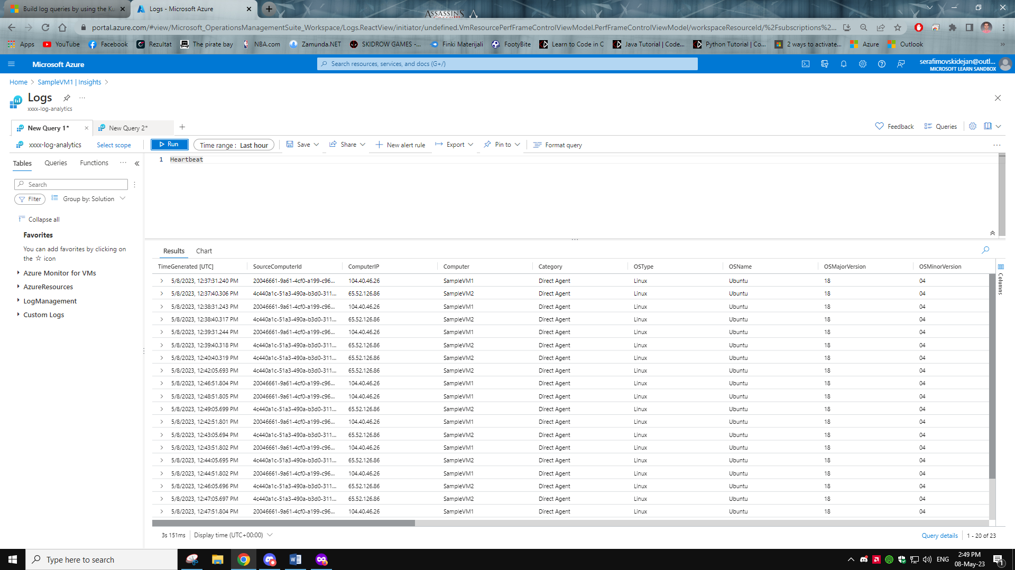

1. Here is the query for Heartbeat of only the two VMs

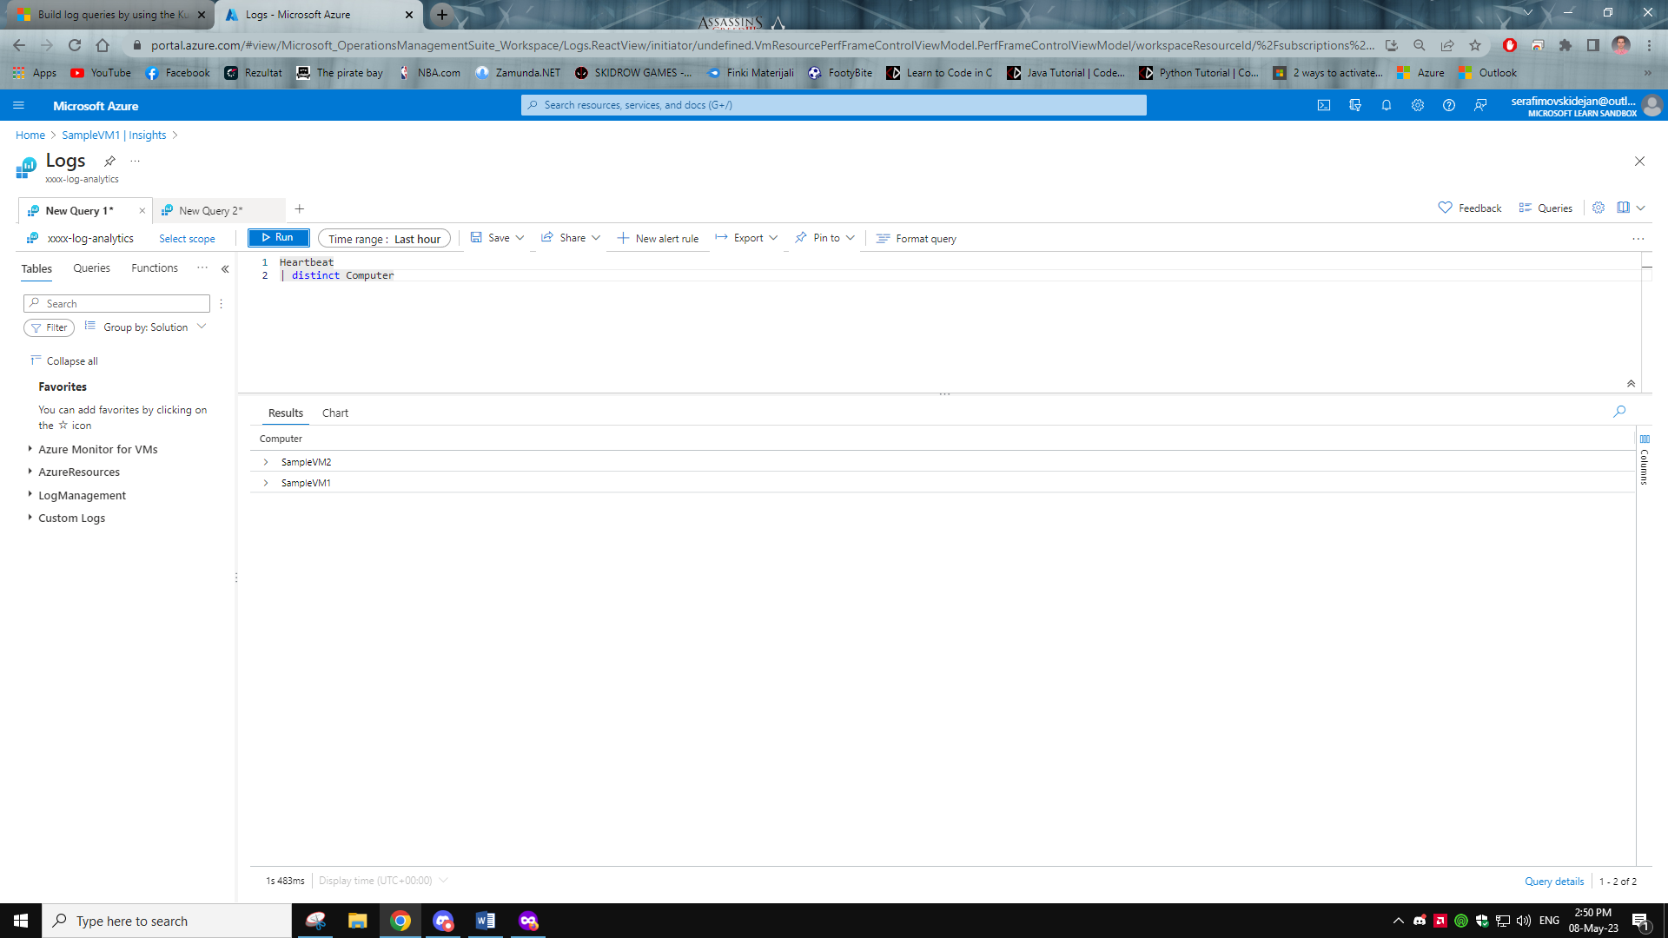

1. After selecting the **Chart CPU usage trends by computer in queries filter menu we can see the CPU usage patterns over the period of time**

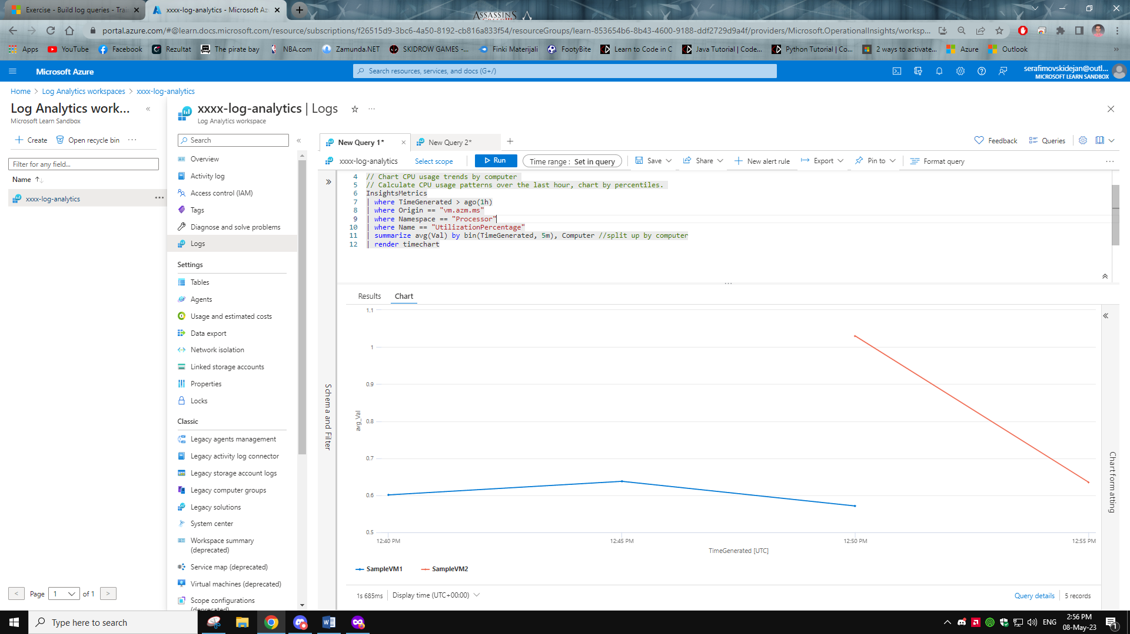

1. Here I have changed the summarize value from average (avg) to maximum (max) and ran it.

It showed me the max CPU usage when it occurred

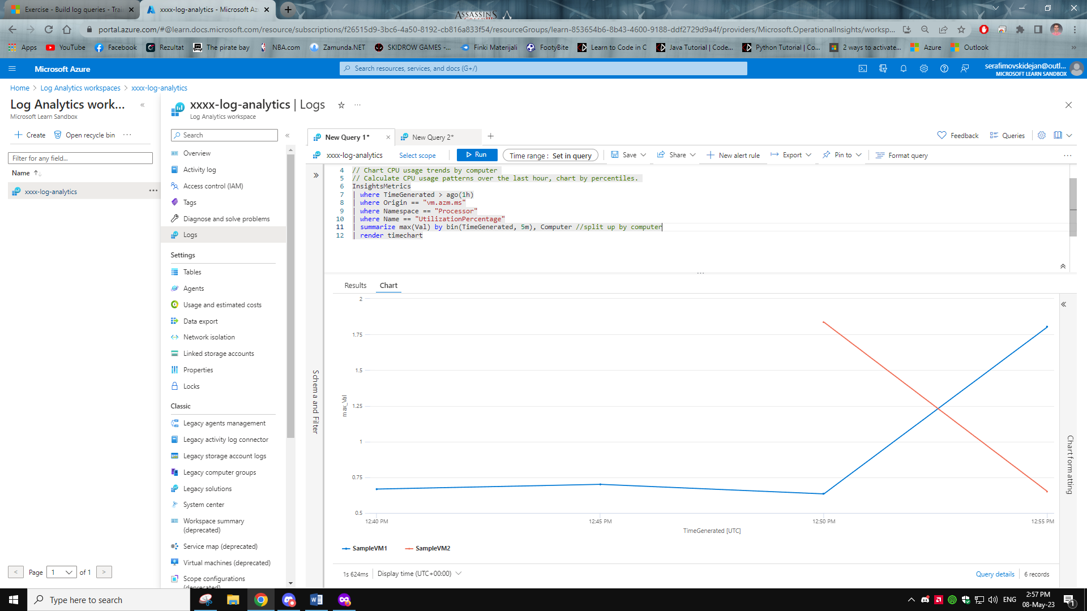

1. Finished with the lab ☺

